EXP NO: 10
Custom Text Styler with Toast Notification in Android

AIM:
Develop an application to change the font and color of the text and display toast message when the user presses the button.
CODE:
MainActivity.kt
package com.example.myapplication_janani_64
import android.graphics.Color
import android.os.Bundle
import android.widget.Button
import android.widget.TextView
import android.widget.Toast
import androidx.activity.enableEdgeToEdge
import androidx.appcompat.app.AppCompatActivity
import androidx.core.view.ViewCompat
import androidx.core.view.WindowInsetsCompat
class MainActivity : AppCompatActivity() {
override fun onCreate(savedInstanceState: Bundle?) {
super.onCreate(savedInstanceState)
enableEdgeToEdge()
setContentView(R.layout.activity_main)
var txt:TextView=findViewById(R.id.textView)
var btn:Button=findViewById(R.id.button)
var count=0
btn.setOnClickListener {
count++
txt.text=count.toString()
txt.setTextColor(Color.RED)
txt.setBackgroundColor(Color.BLACK)
Toast.makeText(this,"Color Change and font",Toast.LENGTH_LONG).show()
txt.textSize=18f
}
}
}

activity_main.xml
<?xml version="1.0" encoding="utf-8"?>
<androidx.constraintlayout.widget.ConstraintLayout xmlns:android="http://schemas.android.com/apk/res/android"
xmlns:app="http://schemas.android.com/apk/res-auto"
xmlns:tools="http://schemas.android.com/tools"
android:id="@+id/main"
android:layout_width="match_parent"
android:layout_height="match_parent"
tools:context=".MainActivity">
<TextView
android:id="@+id/textView"
android:layout_width="wrap_content"
android:layout_height="wrap_content"
android:text="Hello World!"
app:layout_constraintBottom_toBottomOf="parent"
app:layout_constraintEnd_toEndOf="parent"
app:layout_constraintHorizontal_bias="0.461"
app:layout_constraintStart_toStartOf="parent"
app:layout_constraintTop_toTopOf="parent"
app:layout_constraintVertical_bias="0.186" />
<Button
android:id="@+id/button"
android:layout_width="wrap_content"
android:layout_height="wrap_content"
android:layout_marginTop="172dp"
android:text="Count"
app:layout_constraintEnd_toEndOf="@+id/textView"
app:layout_constraintHorizontal_bias="0.0"
app:layout_constraintStart_toStartOf="@+id/textView"
app:layout_constraintTop_toBottomOf="@+id/textView" />
</androidx.constraintlayout.widget.ConstraintLayout>

OUTPUT: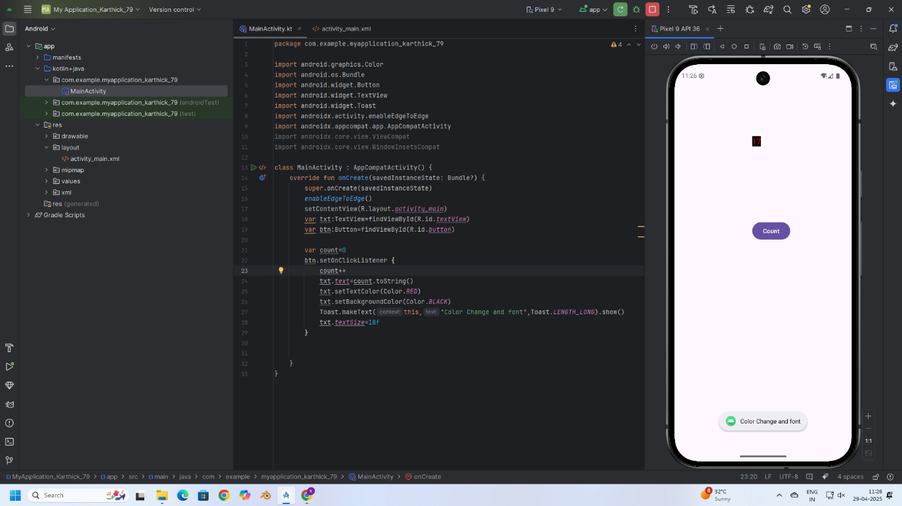
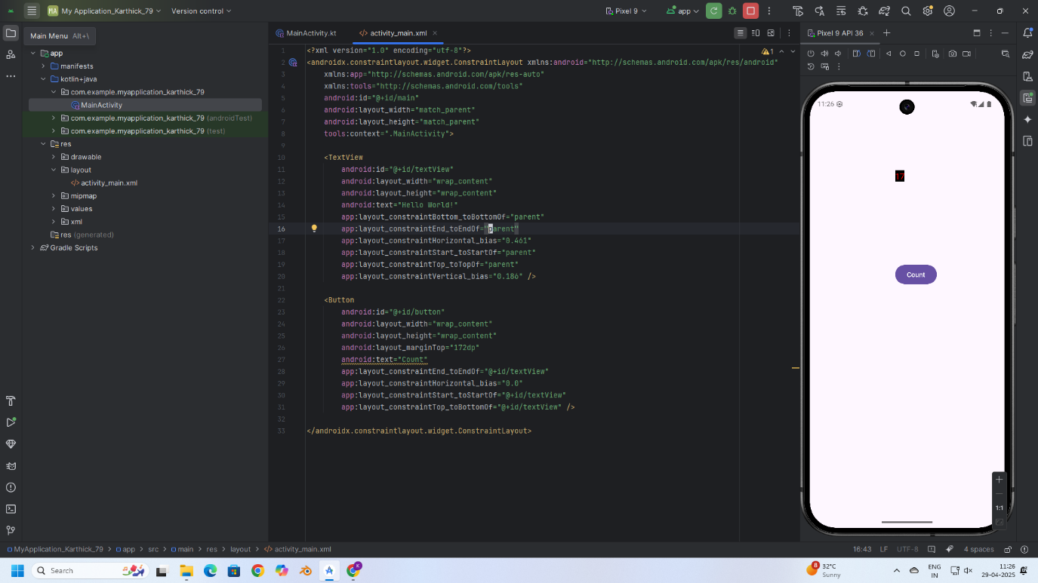
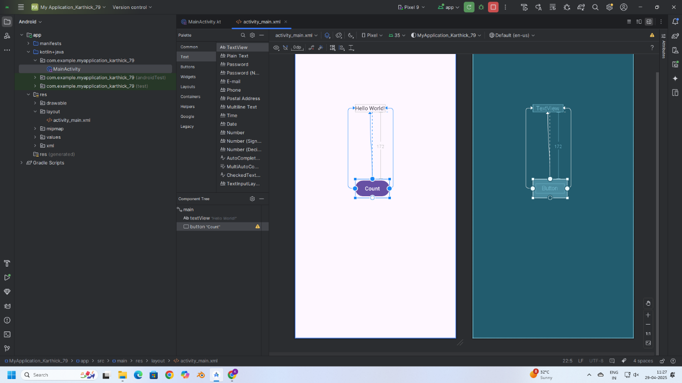

RESULT:
Thus, text customization and user interaction were successfully implemented by changing font and color, and displaying a Toast message on button click in the application.

